Statistics for Engineers Digital Assignment – 6

Name –Avipriya Ghosh

Registration Number – 19BIT0031

1. **A firm wishes to compare four programs for training workers to perform a certain manual task twenty new employees are randomly assigned to the training programs, with 5 in each program at the end of the training period, a test is conducted to see how quickly trainees can perform the task the number of times the task is performed per minute is recorded for each trainee.**

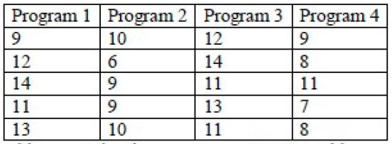

Calculate and interpret the above one way ANOVA table.

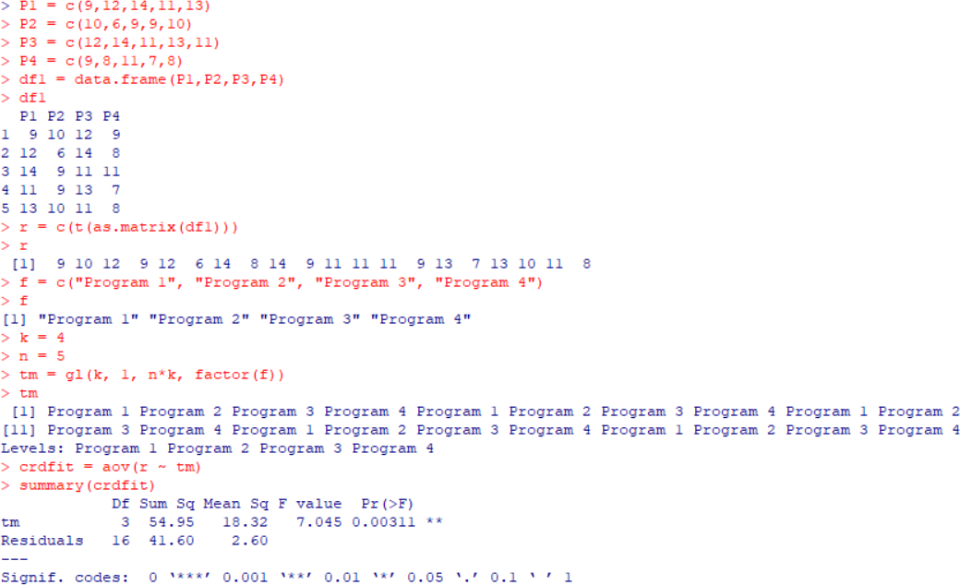

**P-value = 0.00311**

1. **In a factory producing edible oil and marketing its product in 15 kg tins, uses five filling machines. random samples of the packed tins were taken for each machine A, B, C, D and E were presented below.**

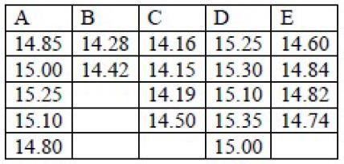

Analyse the data to test the equality of efficiency of machines.

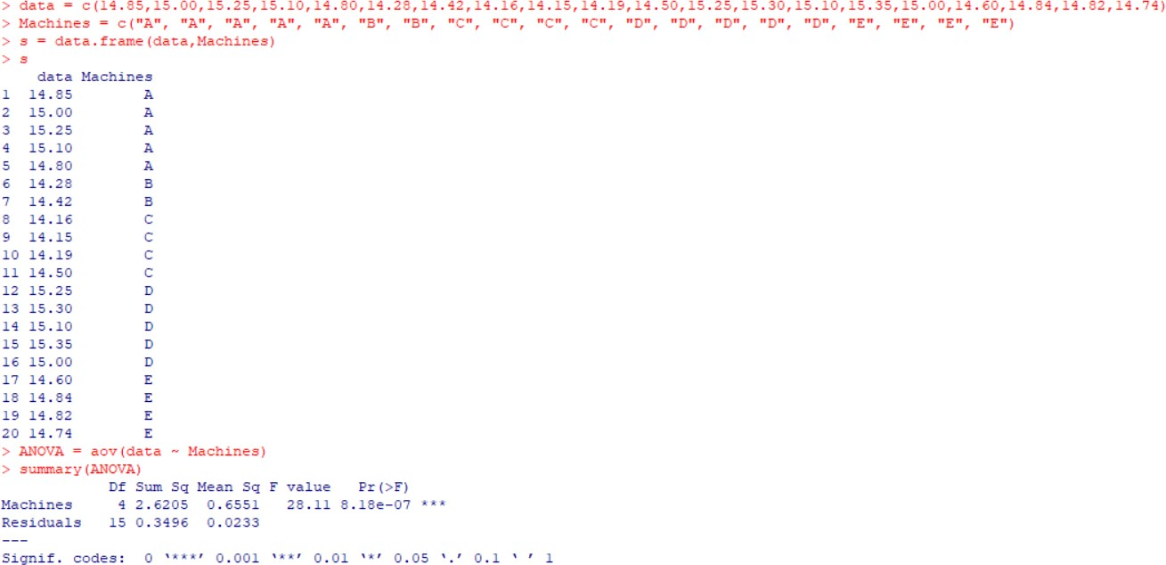

**H0 :** μ1 = μ2 = μ3 = μ4 = μ5

**H1 :** μ1 ≠ μ2 ≠ μ3 ≠ μ4 ≠ μ5 P-value = 0.0000

Since the P-value is less than 0.05 LOS, we’ll reject H0 and accept H1. Hence all the machines are not equally efficient.